

PROJECT REPORT

AI BLOGNEST API

YEAR : 2025 – 20226
COLLEGE NAME : K.C.S KASI NADAR COLLEGE OF ARTS & SCIENCE
CODE : UNM203
DEPARTMENT : COMPUTER SCIENCE
PROGRAM : B.C.A
SEMESTER : V
PROJECT SUBMITTED TO: UNIVERSITY OF MADRAS /
VETRI THIRAN PAYIRCHI THITTAM
Course Name : AI Augmented Backend Development with
Node JS and MongoDB

TEAM LEADER:
BENISHWAR S
MEMBERS:
1. SANTHOSH S
2. DEVA M
3. DHANUSH G
4. KISHORE S
GUIDED BY: Mrs. R.PADMADEVI
SPOC NAME: Dr.K. LALITHAKAMESWARI
BONAFIDE CERTIFICATE

Certified that this report titled “AI BLOGNEST API” is a bonafide record of the Naan Mudhalvan Project work done by BENISHWAR S (UNM ID unm203212401440), SANTHOSH S (UNM ID unm203212401485),
DEVA M (UNM ID unm203212401442), DHANUSH G (UNM ID unm203212401443) and KISHORE S (UNM ID unm203212401455) under our supervision and guidance, towards the partial fulfillment of the requirements for the award of the Degree of B.C.A of K.C.S. Kasi Nadar College of Arts & Science

Date:

Training Faculty External Examiner

BLOGNEST API
AI-POWERED BLOG CONTENT MANAGEMENT BACKEND
BlogNest is a secure and modular RESTful backend platform developed to simplify blog creation, content management, and AI-assisted writing. The system is built using Node.js and Express.js, with MongoDB and Mongoose providing structured data storage, schema management, validation, and efficient database interaction. It supports essential content-management operations including blog posts, categories, tags, comments, and media metadata, while following a layered backend architecture that separates routing, business logic, data management, and service-level operations.

Security and controlled access are central to the platform. BlogNest uses JWT-based authentication, bcrypt.js password hashing, and role-based authorization for Admin, Editor, Author, and Reader users. The backend also incorporates request validation, input sanitization, centralized error handling, rate limiting, and structured logging to improve reliability and protect application resources. Different roles are given different responsibilities within the blog workflow, allowing content creation, editorial review, publishing, comment moderation, and administrative management to be handled through protected API operations.
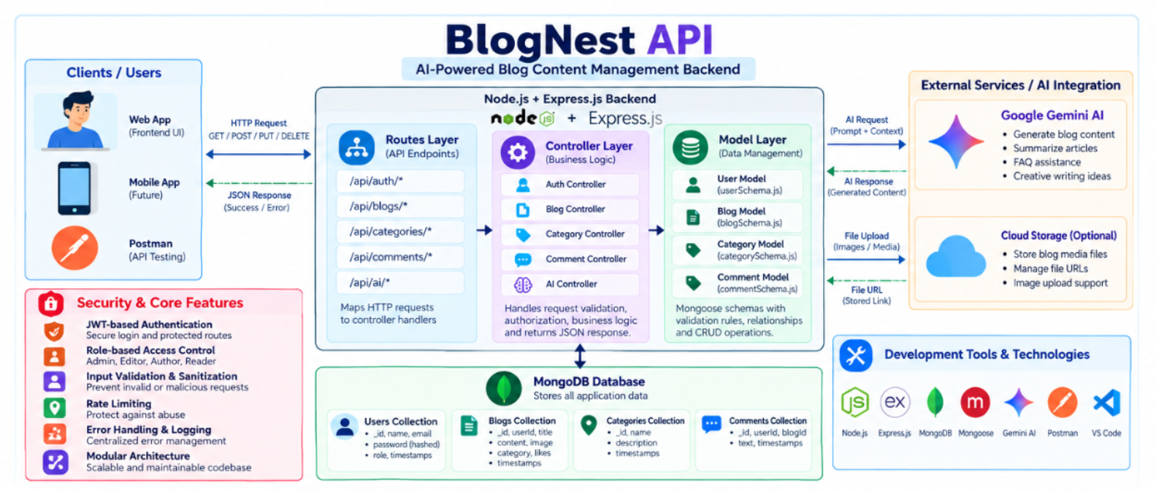

Scenario-Based Case Study

Background
Priya is a content creator who manages multiple blogs but struggles to organize posts, schedule publications, manage categories/tags, and track reader engagement efficiently.

Problem
- Difficulty managing multiple drafts, categories, and tags.
- Limited visibility into post performance and engagement analytics.
- Time-consuming processes for content approval and comment moderation.
- No streamlined system for handling media uploads or metadata.
- Lack of collaborative permission tiers for editors, authors, and administrators.

Solution
The BlogNest backend delivers a centralized, secure API wrapper that decouples application business logic from frontend delivery systems. It introduces an internal permission matrix controlling specialized services for content scheduling, category taxonomy, media path registration, and granular user roles.

Usage
- Author Usage: Creates blog posts, uploads media pathways, organizes content drafts, and reviews their distinct post-performance data.
- Editor/Admin Usage: Accesses protected endpoints to review content queues, change publishing statuses, moderate visitor comments, and orchestrate user privilege upgrades.
- Reader Usage: Queries public list routes to consume posts and invokes comment creation endpoints.

Outcome
By offloading workflow controls to a robust backend, content execution delays are minimized. Data structural integrity is strictly maintained through schema validation, security filters guarantee that only authorized roles perform administrative shifts, and persistent tracking provides raw analytics to measure post optimization metrics accurately.
Software Requirements
- Operating System: Windows 10/11, macOS, or Linux (supports cross-platform operations).
- Node.js (v16 or above): Runtime ecosystem running server logic and routing infrastructure.
- npm (v8 or above): Node package manager to control operational dependencies.
- Express.js: Lightweight routing web framework to construct backend RESTful entry points.
- MongoDB: Document NoSQL engine storing users, posts, categories, comments, and analytics metrics.
- Postman: API verification toolkit to assert schema validation responses across administrative route shields.
- Code Editor: Visual Studio Code or similar IDE environment.

2. Hardware Requirements
- Processor: Intel Core i5 (8th Gen or above) / AMD Ryzen 5 or equivalent.
- RAM: 8 GB minimum (16 GB recommended for concurrent instances of MongoDB, processing layers, and execution nodes).
- Storage: 1 GB of available disk workspace.

Technology glossary
Technology | Role
Node.js | Server-side JavaScript runtime
Express.js | REST API and HTTP routing framework
MongoDB | Document-oriented database
Mongoose | MongoDB ODM and schema/validation layer
JWT | Stateless authentication mechanism
bcrypt.js | Password hashing library
Google Gemini AI | AI service used for intelligent content features
Postman / Thunder Client | API testing tools

Epic:-1 PROJECT ARCHITECTURE


The BlogNest application exposes structured endpoints handled by a layered server architecture model. Incoming requests undergo filter processing before interacting with data services.

Components Definition
- Interface: API tools like Postman query distinct route paths to extract JSON entities.
- Express Server Gateway: Monitors network ports, maps explicit HTTP methods (GET, POST, PUT, DELETE), parses JSON payloads, and handles CORS headers.
- Authentication & Role Matrix Middleware: Extracts tokens from headers, validates user context signatures, and evaluates if the specific role satisfies authorization thresholds for guarded resource paths.
- Granular Services (Logic Modules): Enforces isolated domain rules for blog lifecycles (Draft, Pending Approval, Scheduled, Published), comment queues, and system reporting indicators.
- Database Interface Layer: Mongoose translates operational application logic into performant native MongoDB queries.
- AI Flow (Service Integration): Provides intelligent content automation, including automated blog post generation and real-time content summarization. This layer connects to external AI models via specialized endpoints (/api/ai/generate-blog and /api/ai/summarize), allowing the controller layer to offload complex text processing tasks and enhance content creation workflows.
- BlogGenerator with AI: A specialized service that automates the generation of blog content, which integrates with the AI Flow service to streamline the drafting process.

Entity-Relationship (ER) Diagram Description
The underlying document structure manages several collections bound by logical application references:

1. User Entity
- _id (Primary Key - ObjectId)
- name (String, Required)
- email (String, Required, Unique)
- password (String, Hashed, Required)
- role (String, Default: "reader")

2. Post Entity
- _id (Primary Key - ObjectId)
- userID (Foreign Key referencing User Collection)
- name (String, Required - represents Title)
- photo (Object/String pathway link)
- message (String - Core content body)
- likes (Number, Default: 0)
- timestamps (True)

Key Structural Mappings
- User to Post (One-to-Many): An author can submit multiple blog documents.
- User to Comment (One-to-Many): Readers/Users can append multiple response comments across independent post nodes.
- Post to Comment (One-to-Many): A single blog document stores individual referenced comment submissions.

Key Features
- Role-Based Route Guarding: Strict token processing blocks unauthorized tiers from modifying core settings.
- CRUD Blog Execution Engine: Complete schema management over content definitions, status states, and asset assignment paths.
- Categorization System: Native tag indices facilitate filtering and querying for enhanced discoverability.
- Comment Moderation Logic: Protected entry points for updating moderation flags (approved, pending, spam).
- Sanitization Safeguards: Payload parameter sanitation prevents XSS vectors and NoSQL parameter manipulation injections.
- I-Driven Blog Generation Pipeline: Integrates external Large Language Model (LLM) abstractions and context-aware prompt templates to synthesize full-length, structured blog posts from high-level thematic inputs.
- Intelligent Content Summarization Engine: Leverages semantic compression layers to parse extensive article payloads, dynamically generating concise abstracts and automated metadata summaries.

Roles and Responsibilities
- Admin: Complete environment override control. Can manage user database registrations, alter role assignments, prune malicious comments, and inspect full logging entries.
- Editor: Focuses on editorial workflows. Reviews pending draft posts, marks records for instant publication, and handles category cleanup scripts.
- Author: Restricted account access. Can issue creation statements only for posts bound to their explicit account record.
- Reader: Consumer access profile. Reads published materials and posts comments under an ongoing authenticated identity.
User Flow:


MVC Architecture Pattern
The system architecture structures its source configuration layers around the Model-View-Controller design pattern to completely decouple components:


Model Layer (Data Blueprint)
Defines structure blueprints via strongly enforced Mongoose schemas mapping explicit fields into raw collection items inside MongoDB. It sets default states, indexing rules, and transformation parameters before validation persistence occurs.

Controller Layer (Execution Matrix)
The intermediary brain of the ecosystem. It captures request vectors from the execution routes, checks structural request constraints, delegates processing workflows directly to models, and packages the resultant output into standard JSON return arrays.

View Layer (Routing Network Interface)
In this pure headless backend service context, standard user-interface template views do not exist. Instead, the interface layer lives as an API Routing Layer. It links network requests on specified paths directly to their associated controller handler logic maps.

Epic2: Project Setup and Configuration
Creating project folder

1. Create a new folder with your <project name>.
2. Inside that folder create one new folders.
3. Name another one as Server.
4. Now open that folder in VS Code.
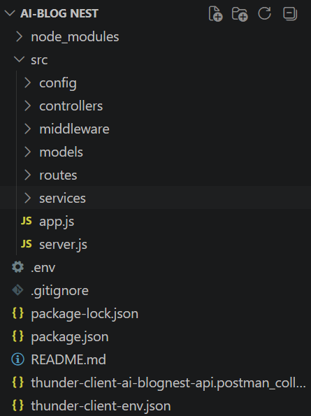

Server setup (npm init)
  - Open Server folder in terminal of VScode.
    - npm init -y
  - Create files:
    - server.js
  - Create folders:
    - models
    - controllers
    - routes
Epic 3: Backend Development
Server.js

App.js


Epic4: Database Configuration
DB Connection:-

1. Configure MongoDB:
- Install Mongoose.
In your Node.js project directory, run:
npm install mongoose
- Create database connection.
- Create Schemas & Models.

Create Database connection:
Now, make sure the database is connected before performing any of the actions through the backend. The connection code looks similar to the one provided below

Mongoose Schema Definitions

1. Identity Resource Document Schema (schemas/userModel.js)
Enforces field criteria validations on incoming database creations:
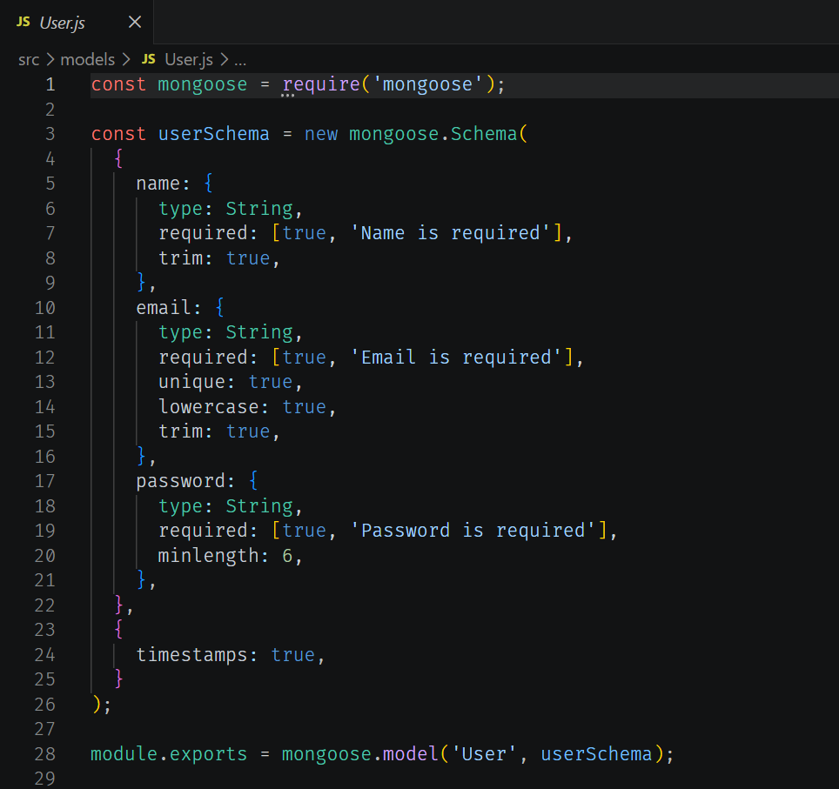

Epic 5: Project Executions:
· Install Postman or ThunderClient (VS Code extension).

· Start the backend server:
“npm start”

API Testing
User Registration:
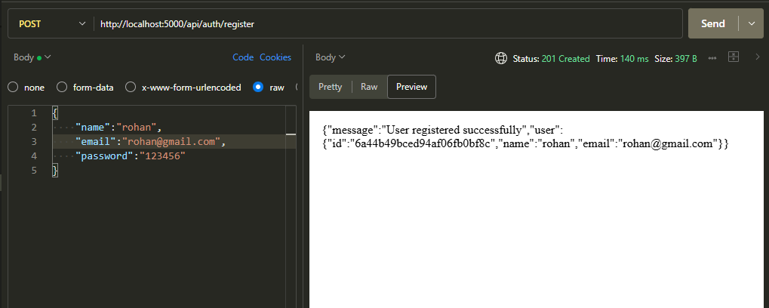
User Login:
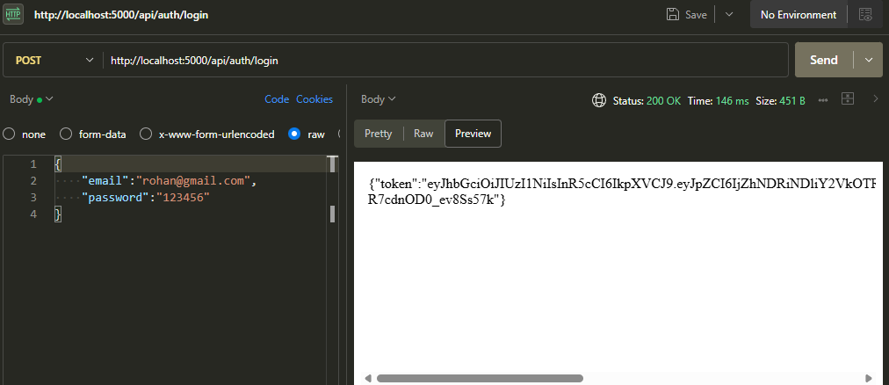
Create Blogs :
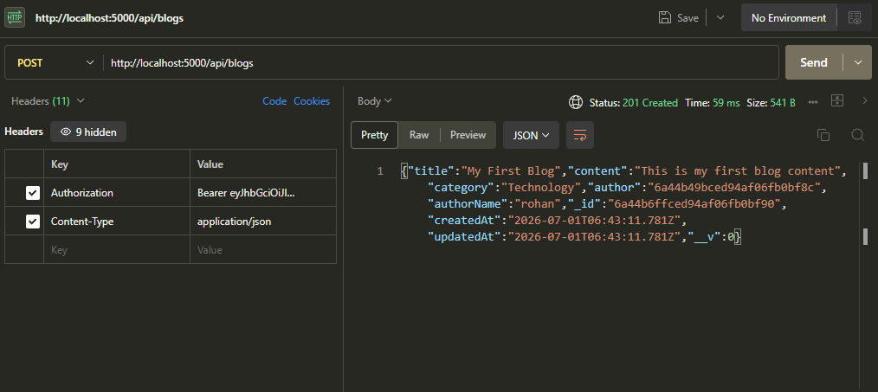
Fetch Blogs :
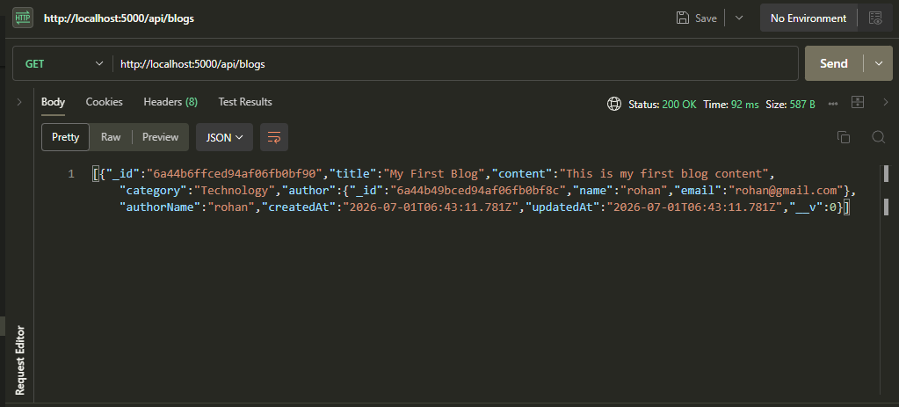

Generate AI blogs:
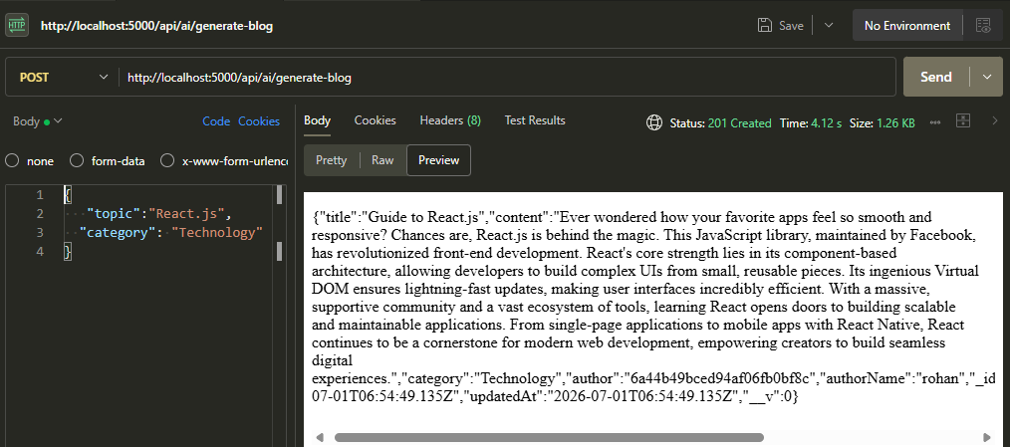

Summarize Blogs :
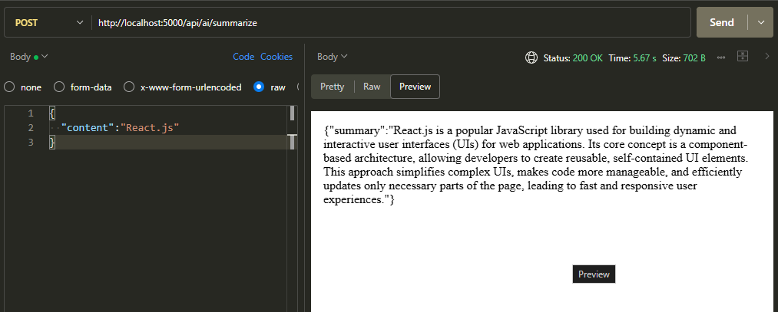

FUTURE ENHANCEMENTS
Possible Enhancements
- Improved User Interface: Develop a simple and user-friendly frontend to make blog management easier.
- Advanced Search: Add options to search blogs by title, category, or keywords.
- Profile Management: Allow users to update their names, email addresses, and profile details.
- Password Reset: Provide a facility for users to reset forgotten passwords.
- Image Upload: Make uploading and displaying images in blog posts easier.
- Like and Bookmark Features: Allow readers to like blogs and save their favourite posts for later.
- Comment Notifications: Notify authors when readers add comments to their blog posts.
- Improved AI Features: Enhance AI blog generation and summarization to provide more useful results.

Github Link - https://github.com/Benishwar/BlogNest_API
Demo video Link – https://drive.google.com/file/d/1X53qSe3L9-CcPPd6sYyw9LO__uZ3t1T3/view?usp=sharing

